Using NPM package [**aem-clientlib-generator**](https://github.com/wcm-io-frontend/aem-clientlib-generator) we can copy all compiled front end code (compiled by Webpack) [sass,scss,less, >ES5 ]to clientlibs folder which we specify in ***clientlib.config.js***

Here we are trying to save all the compiled code at ./webpack.modules

# Webpack.config.js

var path = require('path');

var miniCssExtractPlugin = require('mini-css-extract-plugin')

module.exports = {

    entry : './js/feedback.js',

    output : {

        filename :'final.js',

        path: path.resolve(__dirname,'webpack.modules')

    },

    mode:'none',

    module:{

        rules:[

            {

                test:/\.css$/,

                use :[miniCssExtractPlugin.loader,'css-loader']

            },

            {

                test:/\.js$/,

                exclude:/(node_modules)/,

                use:{

                    loader:'babel-loader',

                    options:{

                        presets: ['@babel/preset-env']

                    }

                }

            }

        ]

    },

    plugins:[

        new miniCssExtractPlugin({

            filename:'final.css'

        })

    ]

}

We run webpack build along with aem-clientlib-generator together to copy all the compiled code to the target location as configured in ***clientlib.config.js*** as shown below

# Clientlib.config.js

module.exports = {

    context : __dirname,

    clientLibRoot : './../clientlibs/feedback-clientlibs',

libs:{

    allowProxy:true,

    serializationFormat : "xml",

    name:'dcloud-feedback-clientlibs',

    assets:{

        js:[

               'webpack.modules/final.js'

        ],

        css:[

                'webpack.modules/final.css'

        ]

    }

}

};

Once the build is done , below is the folder structure under /apps/

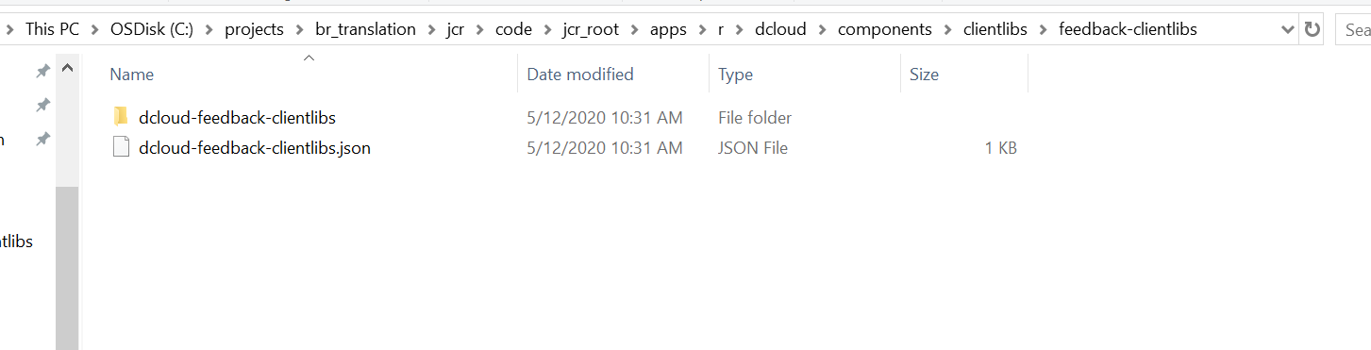

# Useful Resources

Configuring ***clientlib.config.js*** 🡪 <https://github.com/wcm-io-frontend/aem-clientlib-generator/blob/master/README.md>

Sample React+AEM 🡪 <https://helpx.adobe.com/in/experience-manager/kt/sites/using/getting-started-spa-wknd-tutorial-develop/react/chapter-0.html#toc>